Institute of technology of Cambodia

Department of Information and communication Engineering



The lesson taking about basic of loop and prime numbers

TP5-Loop (for loop while loop and do while loop)

TP: Algorithm and Programming

Lecturer: BOU CHANNA

Student: VEN THON

ID: e20191250

Group: I3-GIC-C

Year: 2021-2022

Contents

Problem1: Write a C program to get st and en from a user, Find summation and multiplication of numbers 3

Problem2: Write a C program to get numbers, say m and n, on screen using 'for' loop, 'while loop', and 'do while' loop. 4

Problem3: Write a C program to generate 10 random numbers in between [10, 10000]. 5

Problem4: Write a C program to check whether an input number is a primary number or not. 6

Problem5: Write a C program to find maximum number between 10 numbers entered by the user 7

Problem1: A program to get st and en from a user,

where st is a starting number and en is an ending number.

Find summation and multiplication of numbers from st to en.

----

st: 2

en: 5

SUM: 2+3+4+5=?

MULTIPLY: 2*3*4*5=?

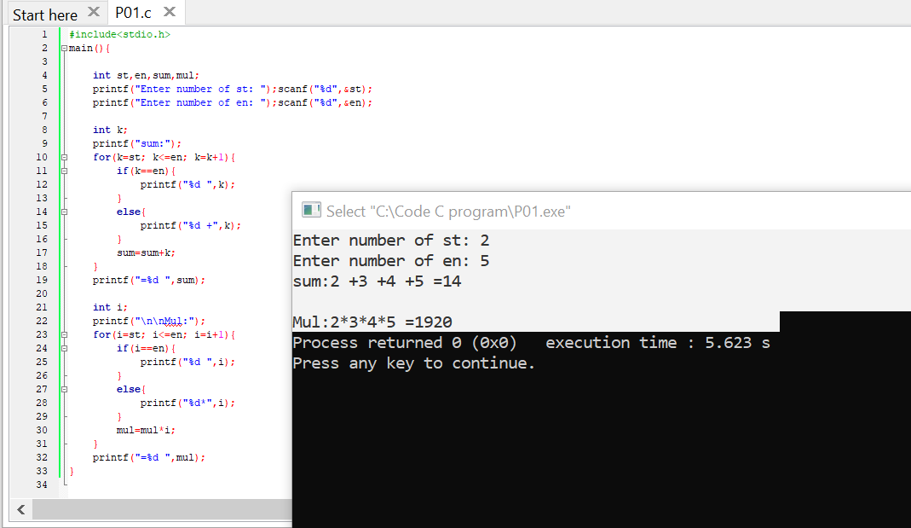

Problem2- Write a C program to get numbers, say m and n, from a user.

Display numbers in between [m, n] on screen using 'for' loop, 'while loop', and 'do while' loop.

----

m: 5

n: 100

=> Display 5 6 7 8 ... 100

=> Display 5 6 7 8 ... 100

=> Display 5 6 7 8 ... 100

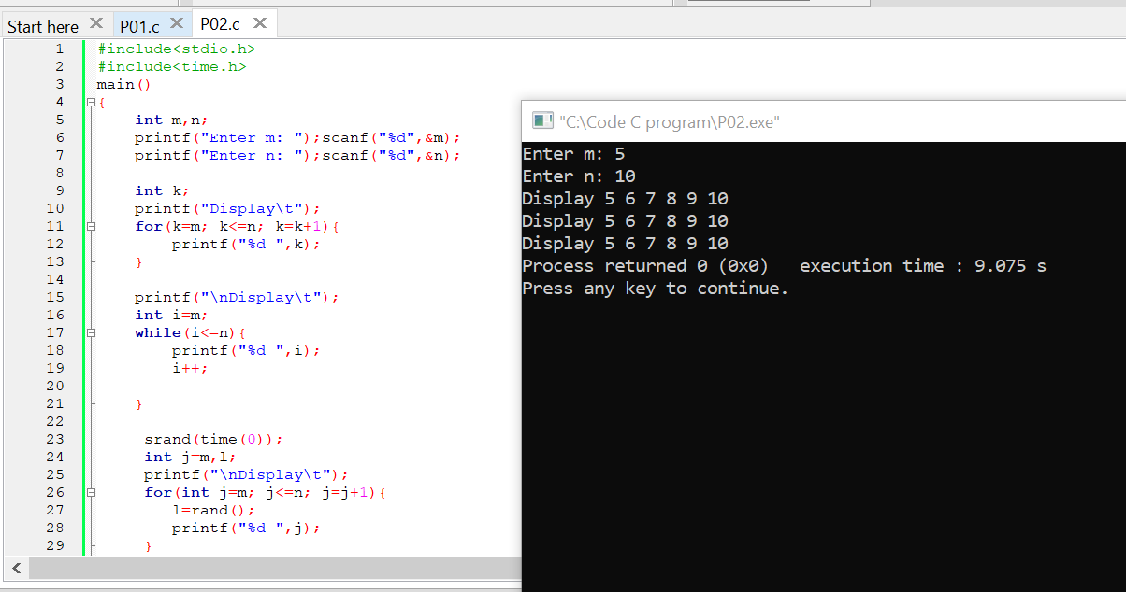

Problem3- Write a C program to generate 10 random numbers in between [10, 10000]. Display those randomized numbers on screen.

-----

=> 20 79 193 284 999 ...

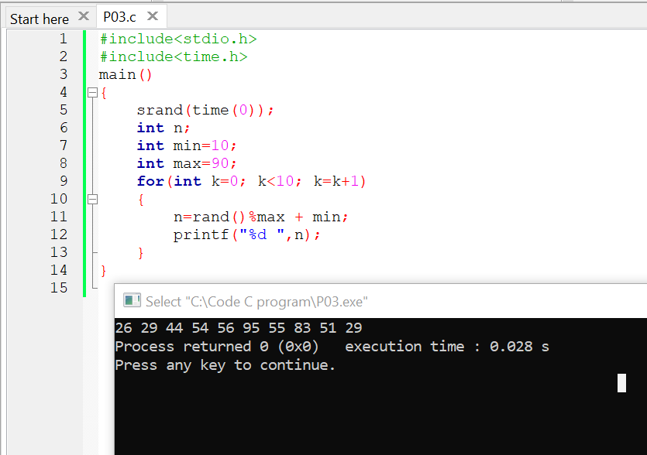

Problem4- Write a C program to check whether an input number is a primary number or not. Display "Primary" if it is a primary number. If not primary, display "NOT primary!".

Remark: Keep the program running again so that we can always check another input number.

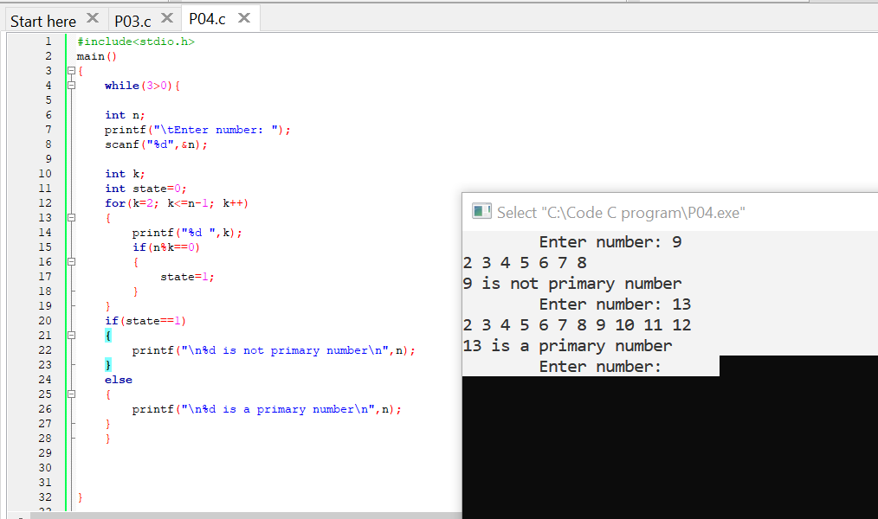

Problem5- Write a C program to find maximum number between 10 numbers entered by the user. You are not allowed to create 10 variables for that numbers.

Hint:

 -Use 'for' loop, make it run 10 times

 -Get each input inside loop. Check and update max value.

